

**Fundamentals for IT Professionals II**

Year 2 (2022/23), Semester 3

**SCHOOL OF INFOCOMM TECHNOLOGY**

Diploma in Information Technology

Diploma in Date Science

Diploma in Immersive Design

**Assignment 2**

**Industry Engagement**

**Duration:** Weeks 12 - 14

**Weightage:** 20%

**Individual/Team/Both:** Individual

**Deadline:** Report

Softcopy (submit to BrightSpace)

**24 Jul 2022, 2359, hr (Sunday)**

|  |  |
| --- | --- |
| **Student ID** | **S10221788K** |
| **Name** | **Lim Wee Liang Kelven** |
| **Module Group** | **T02** |
| **Grade** |  |

Contents

Industry 1: Workato 3

Details of industry visit 3

Expectations 3

Office 3

Staff 3

Activity 3

How I felt 4

Nature of industry 4

Reason for attending the industry visit 4

Relevancy of industry visit to course of study 5

Impact of industry visit on future goals 5

Industry 2: SAP 5

Details of industry visit 5

Nature of industry 6

Reason for attending visit 6

Relevancy of industry visit to course of study 6

Impact of industry visit to future goals 7

Pictures 7

Workato 7

SAP 14

# Industry 1: Workato

## Details of industry visit

### Expectations

Before the visit, I expected Workato to be a stern and professional company. To elaborate, I expected the staff to reprimand the students if they wandered off or chatted loudly. In contrary to my expectations, the staff and whole office in general had a calming aura and the staff were warm and patient with us.

### Office

The office was vast. It had multiple meeting rooms with unique names, two kitchens, a table tennis table, and a magnificent view of the city. It also had walls for staff could brainstorm and write their ideas on. One interesting thing I noticed was that there were no typical office cubicles where staff would sit four walls. I asked about this, and the staff said they believed in an open environment where everyone can communicate and help each other.

### Staff

The staff, as mentioned previously, were warm and patient with us. Before the activities, they provided us with snacks and drinks and told us we could take more if needed. I also admired their dedication and enthusiasm as they had to teach two batches of students, which lasted from morning to evening. My visit was in the afternoon, but the staff were still delighted to have us.

### Activity

Before the visit, we had a short meeting with the staff and they mentioned we would be making a recipe, or an automation programme. I was excited yet nervous if I could grasp the lesson. During the visit, some had trouble making the recipe but there were helpers going around to resolve the issues. Personally, I had issues navigating the Workato platform and connecting the different applications together. Despite the issues, it turned out that making the recipes was simple to understand as the platform replaced traditional coding language with basic English, and the attractive and welcoming user interface helped to newcomers.

### How I felt

Before the visit, I felt excited to learn something new. And after the visit, those feelings were warranted as I left with a smile on my face. The activity was entertaining and delightful, which helped reinforce the learning of automation. Even though I was introduced to only the beginning, this visit made me more interested in learning about automation.

## Nature of industry

Workato is an ICT business that helps automate business workflows. These automations can be an intelligent helpdesk, incident management, end-user support, or a bot that receives emails They believe in a low-code automation and hence designed the company to achieve that. They combine various applications like Atlassian, Jira, and Slack into one to achieve a seamless user experience.

Setting up a recipe, or programme, is also easy to understand. Workato replaced traditional coding language with basic English to ensure everyone understands. This simplicity made it likeable and adopted by companies such as Logitech, Broadcom, and Replicon.

## Reason for attending the industry visit

I attended this visit because I wanted to learn more about automation. I had a preconceived notion that automation is an engineering thing. I was surprised to learn that there is automation in ICT. These can be seen in helpdesk bots, bots that help reset passwords, and many more. This piqued my interest and that was why I attended this industry visit. I wanted to learn how these bots were made and how they can be used.

## Relevancy of industry visit to course of study

In the Data Science (DS) course, one of the modules taught is machine learning (ML). We can combine automation and ML into auto machine learning (AML). This AML can be used to collect, prepare, model, and deploy data. These processes can be time-consuming if done manually. Hence, automating this saves time

Apart from DS, automation can also be used in artificial intelligence (AI) to create AI chatbots or AI helpdesks. These can replace traditional helpdesk jobs while still maintaining a form of human interaction.

In summary, implementing automation in ML or AI can help reduce

* Organisational costs
* Human errors
* Time wastage

## Impact of industry visit on future goals

When I joined this DS, the only job I aimed for was becoming a data analyst or scientist because those were two clear choices where I can fully use what I learnt. But now, I learnt that my skills can also applicable elsewhere and not just for being a data analyst. My skills as a programmer could be used in app development or website making, and my understanding in one field can be applied to another field. In summary, this visit enlightened me that my first choices should not be my final choices. Different branches in life may emerge as I grow older.

# Industry 2: SAP

## Details of industry visit

### Office

The SAP office was like Workato’s. It was an open-desk concept with no office cubicles. Staff can sit wherever they like and chat with people from different departments. There were three different levels, each having its own design and charm. On the first level, there was an experience centre. Visitors can view various collaboration projects by SAP and other companies. These projects showcase how SAP utilise their software in various applications. There was also a robotic barista by the main entrance.

### Guided Tour

During the visit, we had a guided tour by the staff and some interns. The tour brought us to the different levels and facilities throughout the office. The staff taught us about the real-world applications of SAP, while the interns shared about their internship experience and work life. And for those of us seeking further studies, they also talked about managing studies and work.

Even though my visit was during morning, the staff were energetic and enthusiastic in their talks and answered all our burning questions.

### Activity

Before the visit, we attended two sharings. One was by the Managing Director (MD), and the other by an intern; both of whom were Ngee Ann alumni. The MD did a short brief of what SAP is about, how they have grown, and their future goals. The intern shared about the challenges faced during her internship and what we can expect from our future internships. I found her talk relevant to me as I would have to take an internship next year and took her advice to heart.

### How I felt

Before the visit, I had thought this would be a normal office tour. But I learnt that SAP is more than just a software. They are expanding their market, making others know that they are a company.

## Nature of industry

SAP is a German-based company with offices around the world. As such, it is a diverse company with different nationalities. A department can have staff from different countries. However, this can also be an issue during team meetings due to differing time zones. Communication plays an important role in the company.

Although SAP is an enterprise resource planning (ERP) software, the company is collaborating with other companies utilising their database software and cloud systems.

## Reason for attending the industry visit

I attended this visit because I wanted to learn how SAP could be applied in a real-world context. During class, I am only taught how to use SAP and its purpose. During the visit, I learnt how the software can be applied in many fields. This allowed me to connect the experience to my learning. Since SAP’s main selling point is its ERP system, I was surprised to learn that it can be applied to things that do not focus on ERP.

## Relevancy of industry visit to course of study

Even though DS mainly teaches me how to code, I can use my knowledge of SAP, in particular the resource planning, during my internship or after graduation. As mentioned previously, the visit opened my eyes to how SAP is not always an ERP software company. So, throughout my studies, I can ideate how certain modules can be applied to certain features, and how a module can be applied to something that seems unrelated.

## Impact of industry visit on future goals

Innovation is always happening. SAP is not only just an ERP software company, but it also expanded and offered its services like database and cloud and attracted more customers. This made me realise that a company known for something should not always be known for that thing. Hence, if I join a company in the future, I should be open-minded and flexible to new things.

# Pictures

## Workato

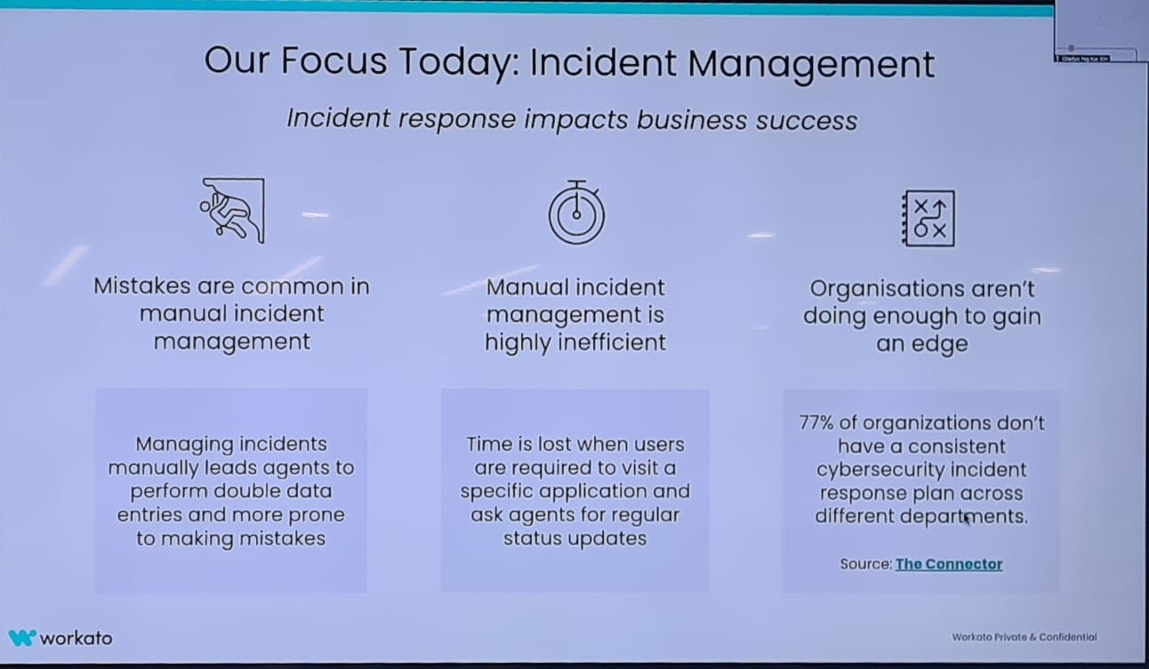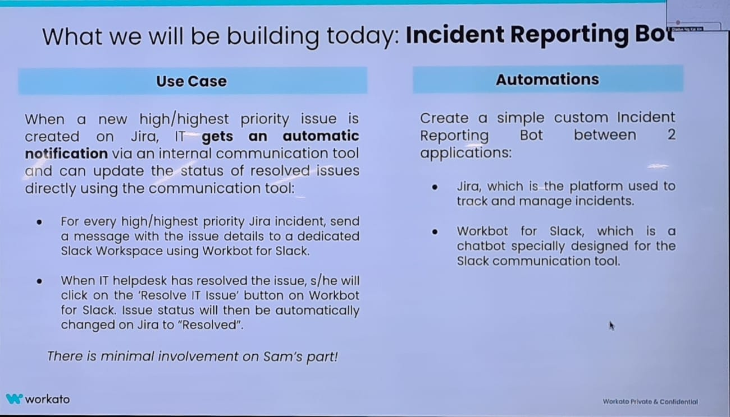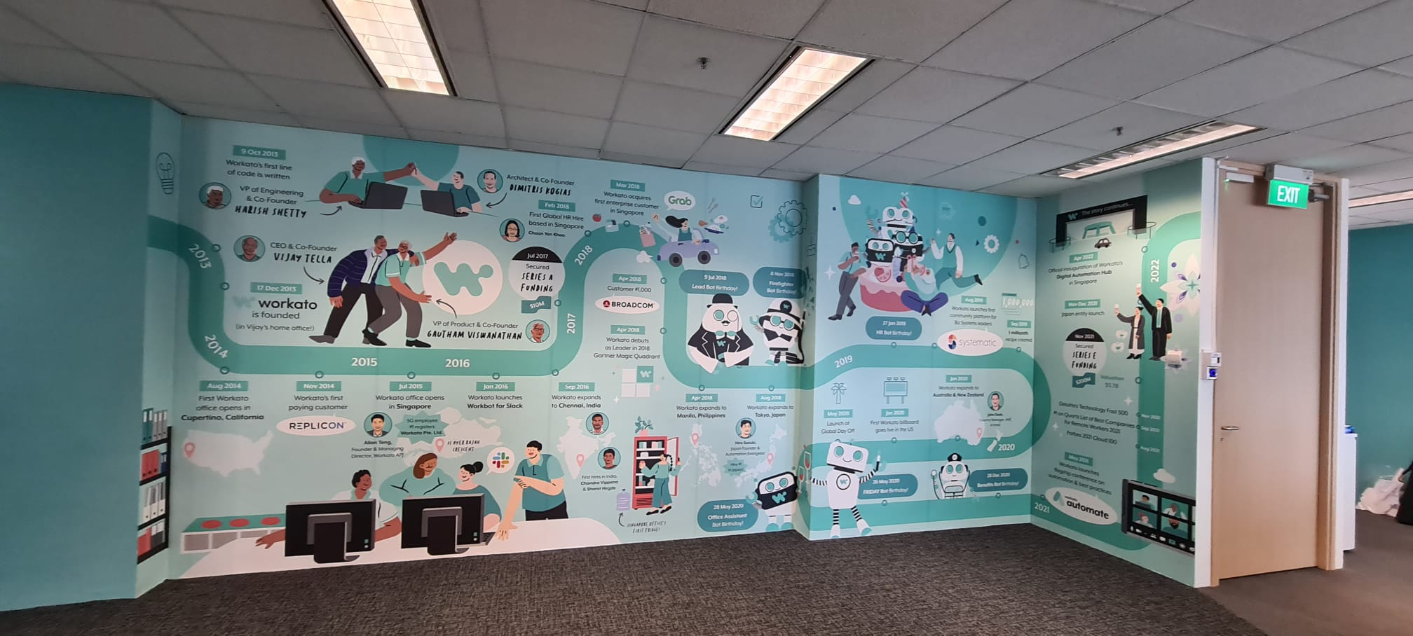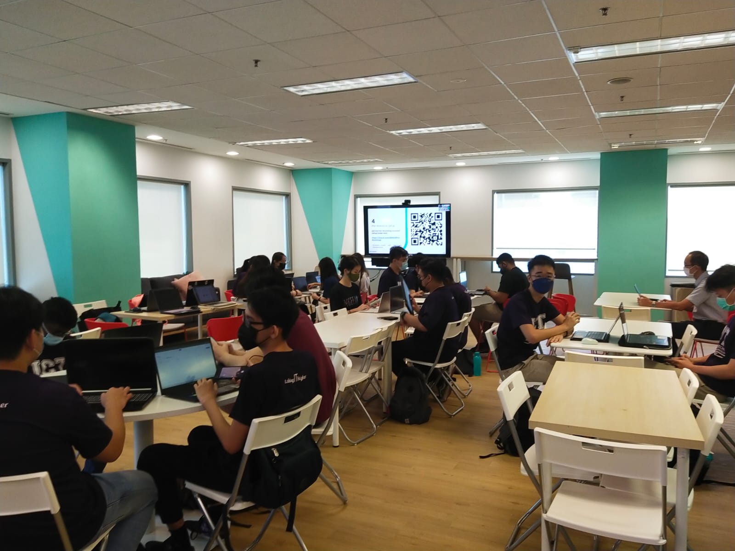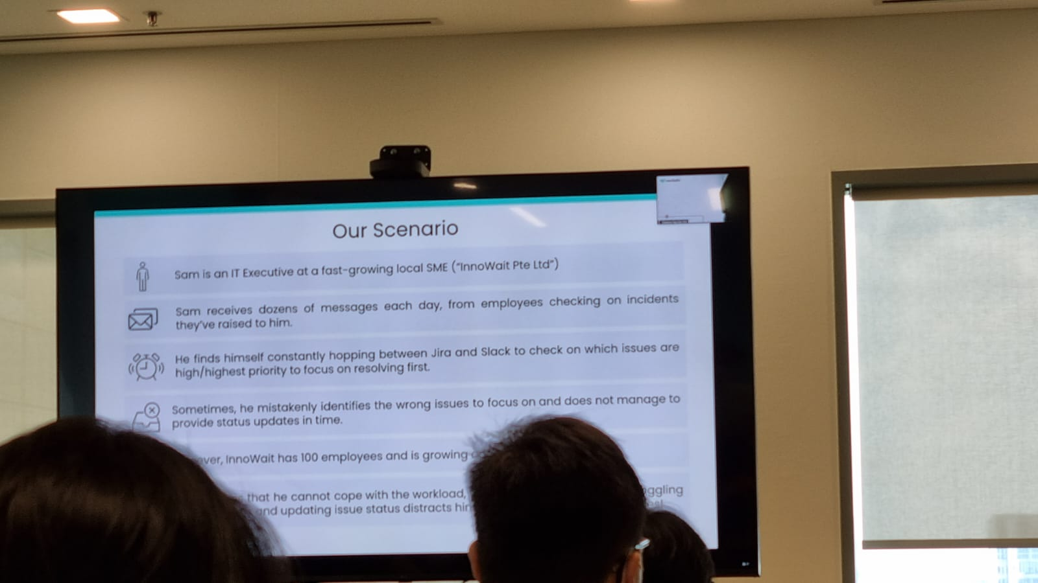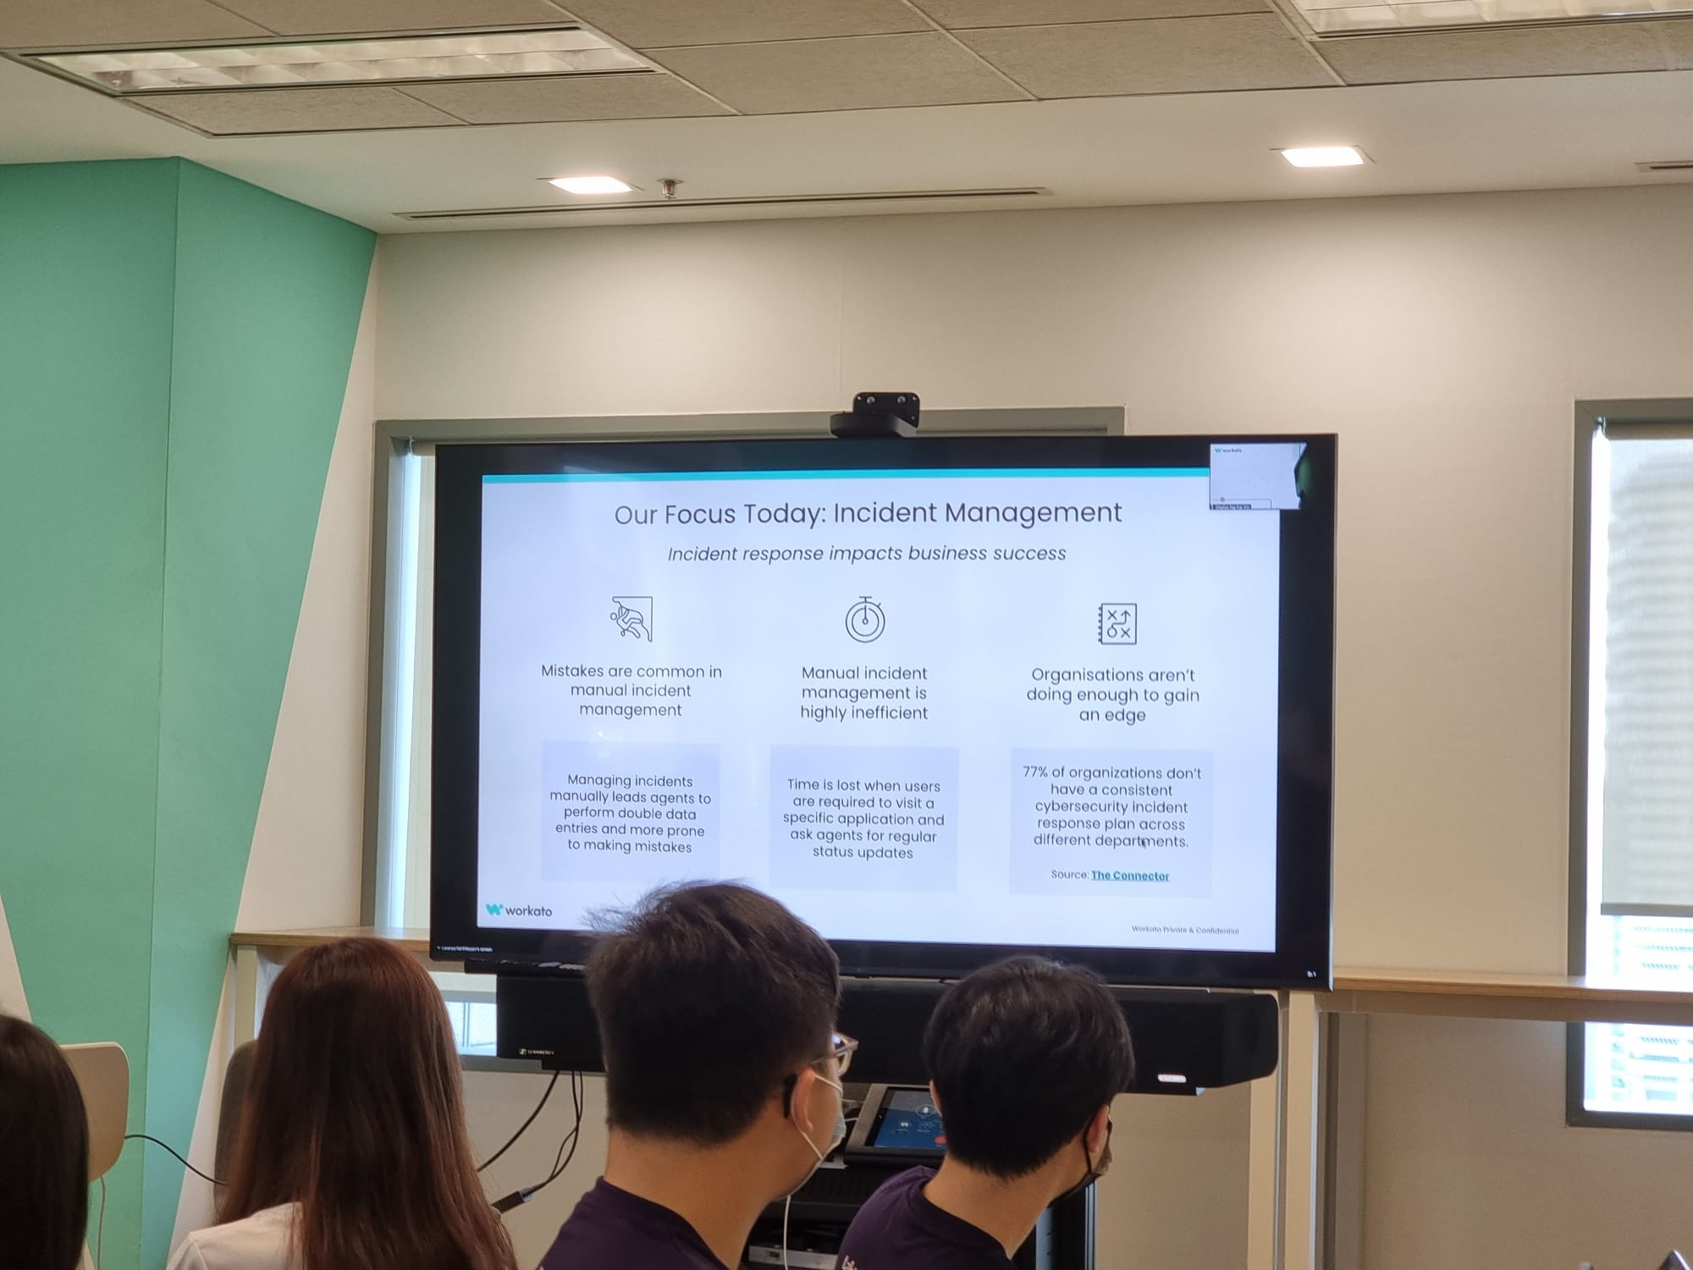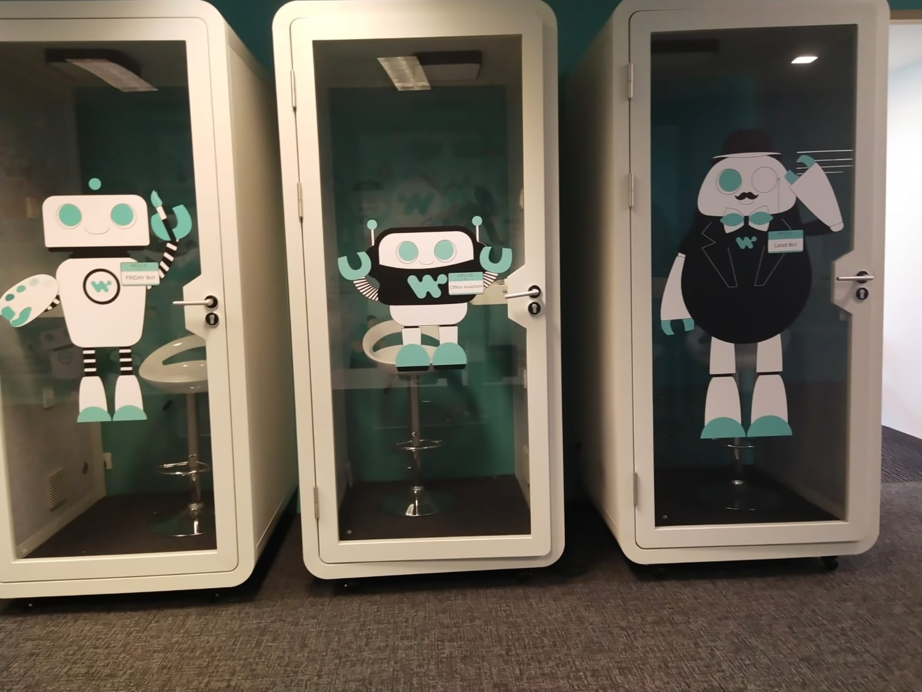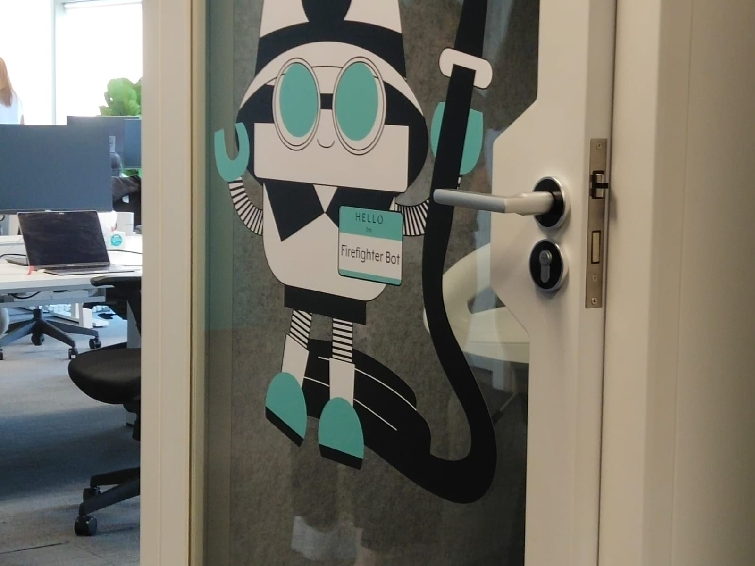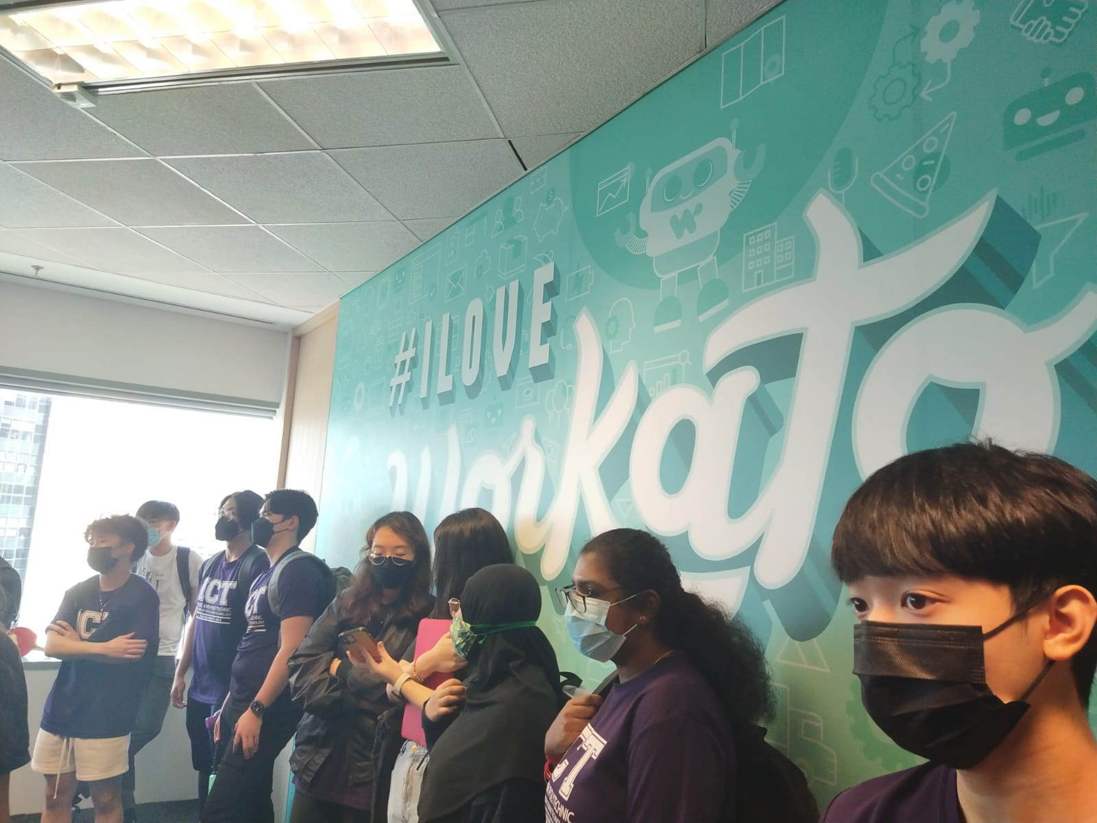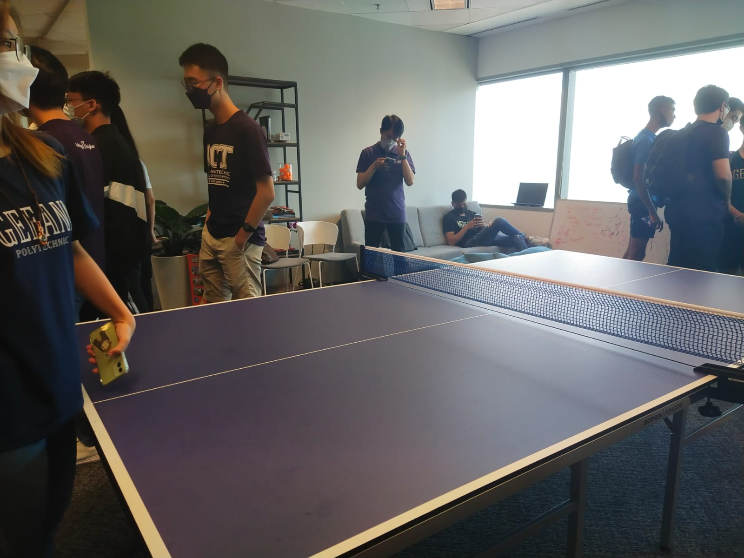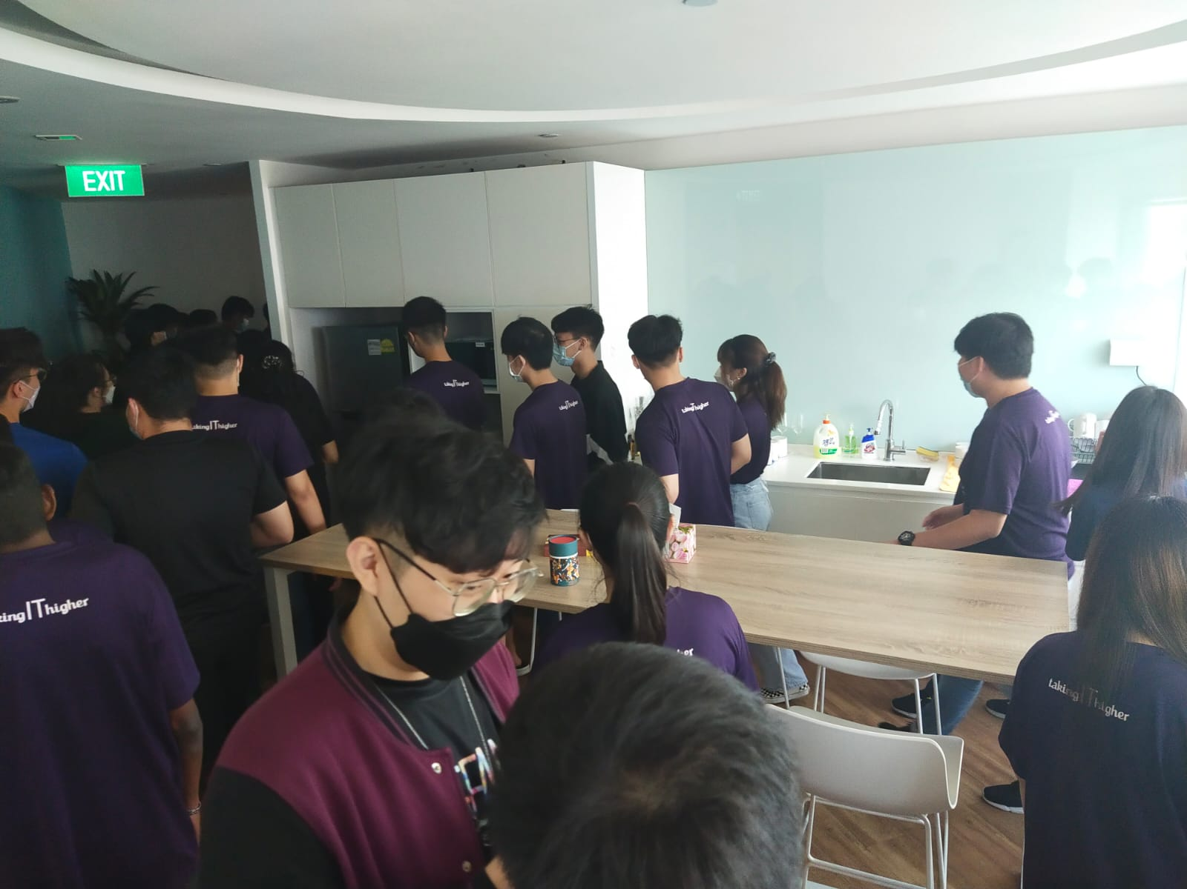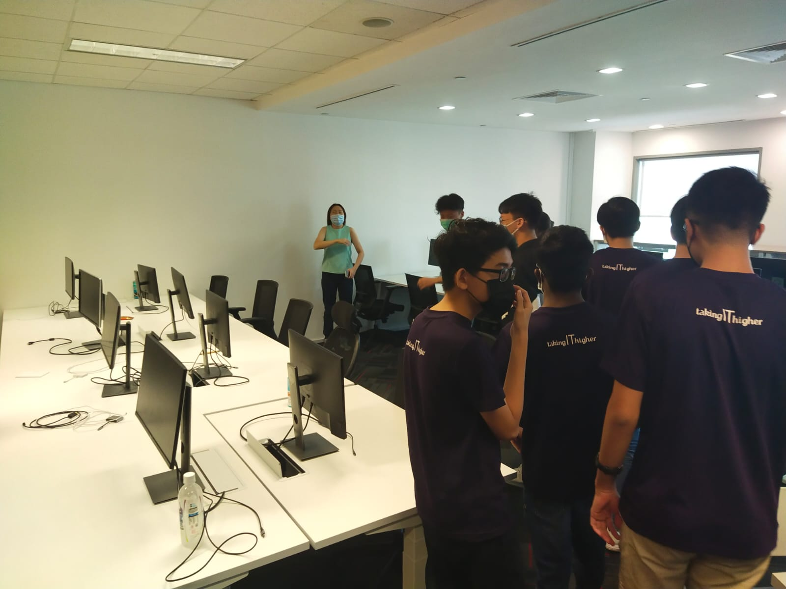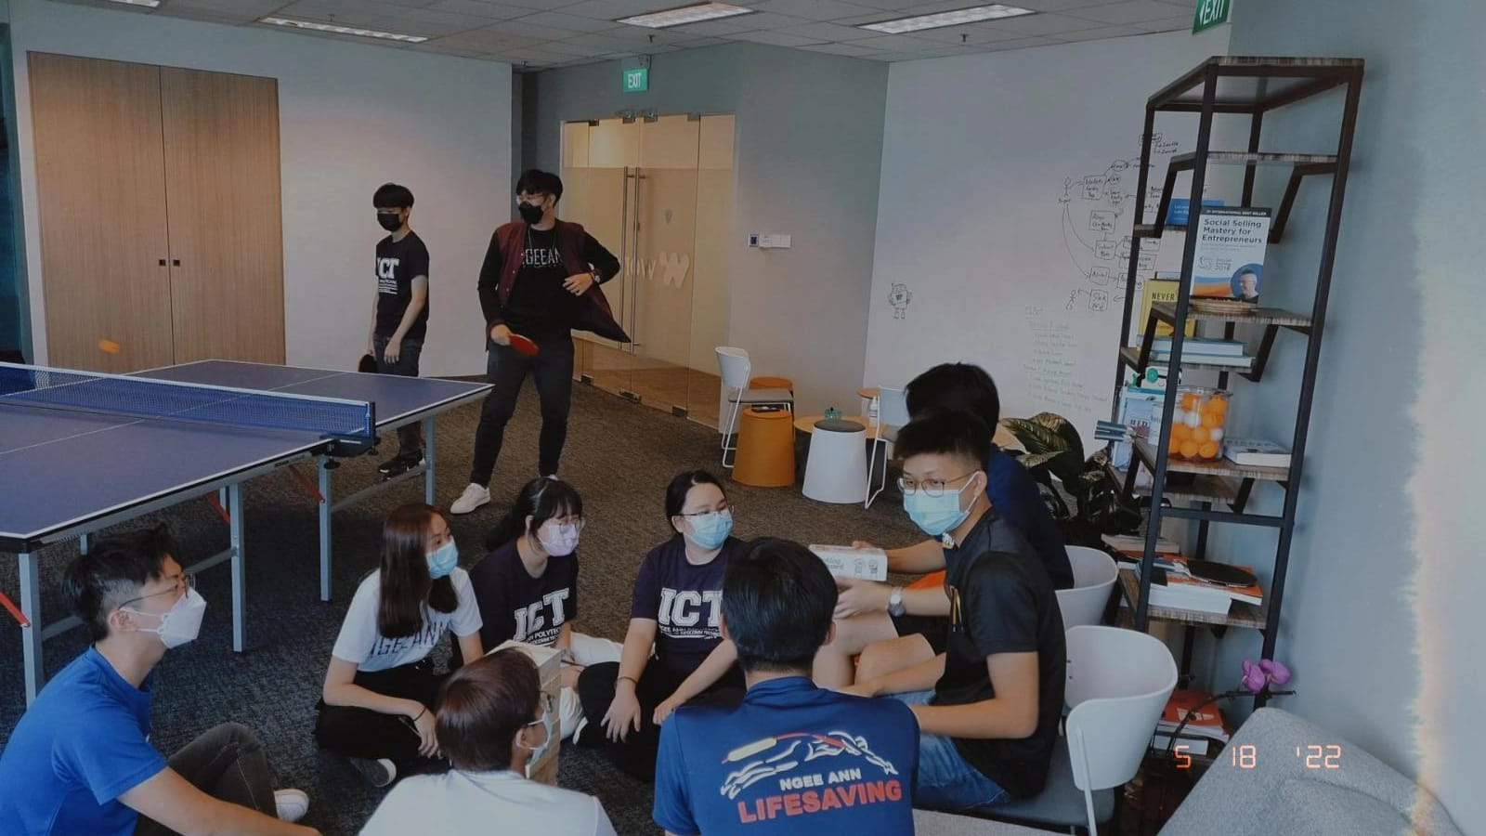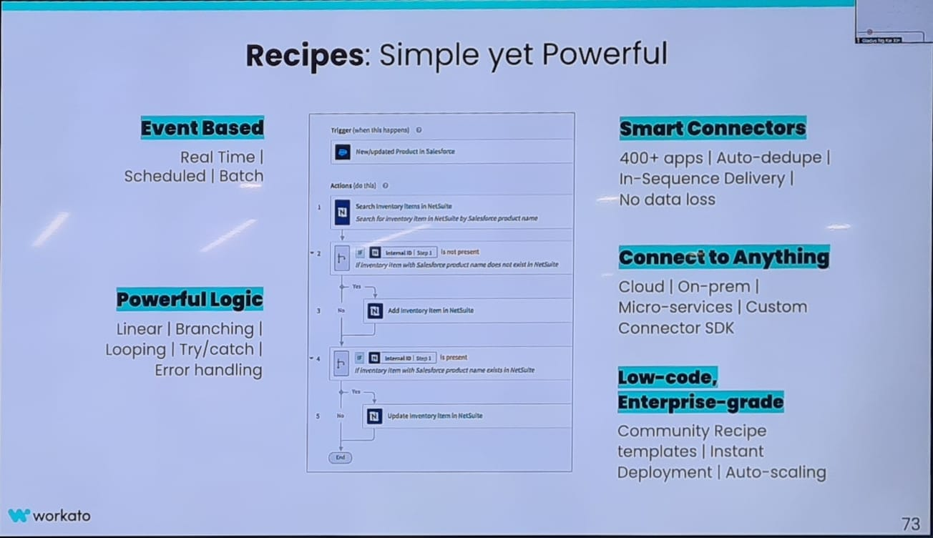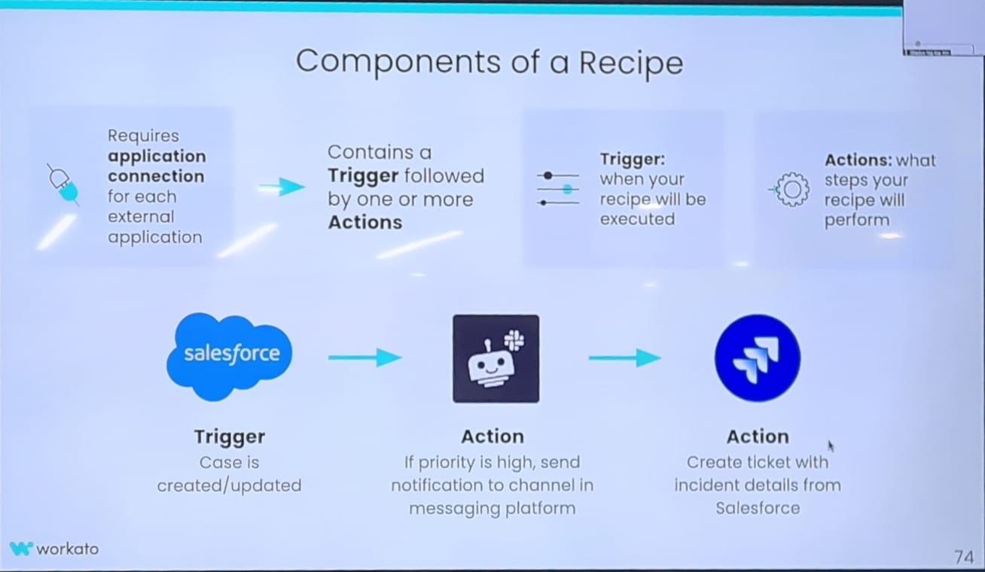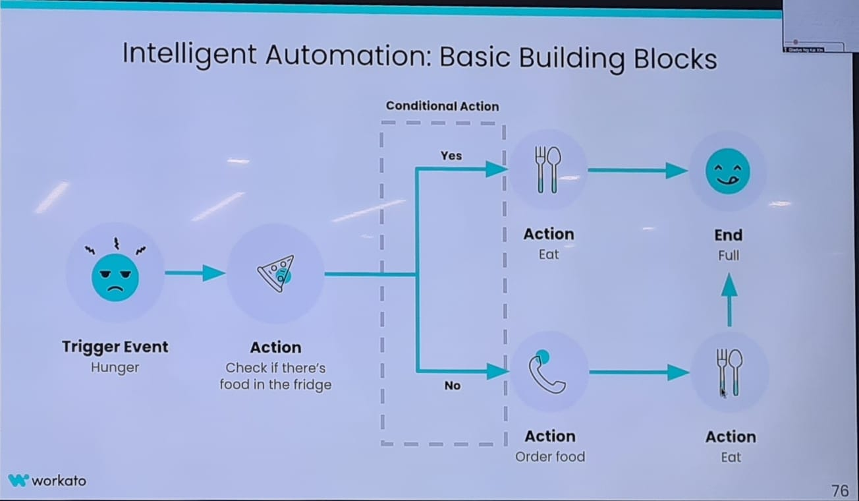

## SAP

